# Department of Computing

# CS 212: Object Oriented Programming

# Class: BSCS-8AB

# Lab 06: Inheritance and Composition in Java

# Date: March 18, 2017

# Instructor: Hirra Anwar

**Learning Objectives**

The learning objective of this lab is to understand and practice the concept of inheritance as well as the concept of containment in Java.

Composition is expressed as Has-A relationship in Java where a class has some relationship with other classes. Is- A and Has-A relationships are two important concepts which need to be practiced and implemented in detail. Some scenarios illustrate involvement of both these relationship and a few focus on just one of them.

In the following tasks, apply most appropriate concepts and solve the problems with the best possible solution.

**Task #1:**

The following hierarchy shows the relationship among classes of Person, Student, Faculty and Job. Create these classes individually with the given data members and add the methods according to relevance on your own. Also create constructors, copy constructor and getter setter methods and a Test class to create objects of each class and test.

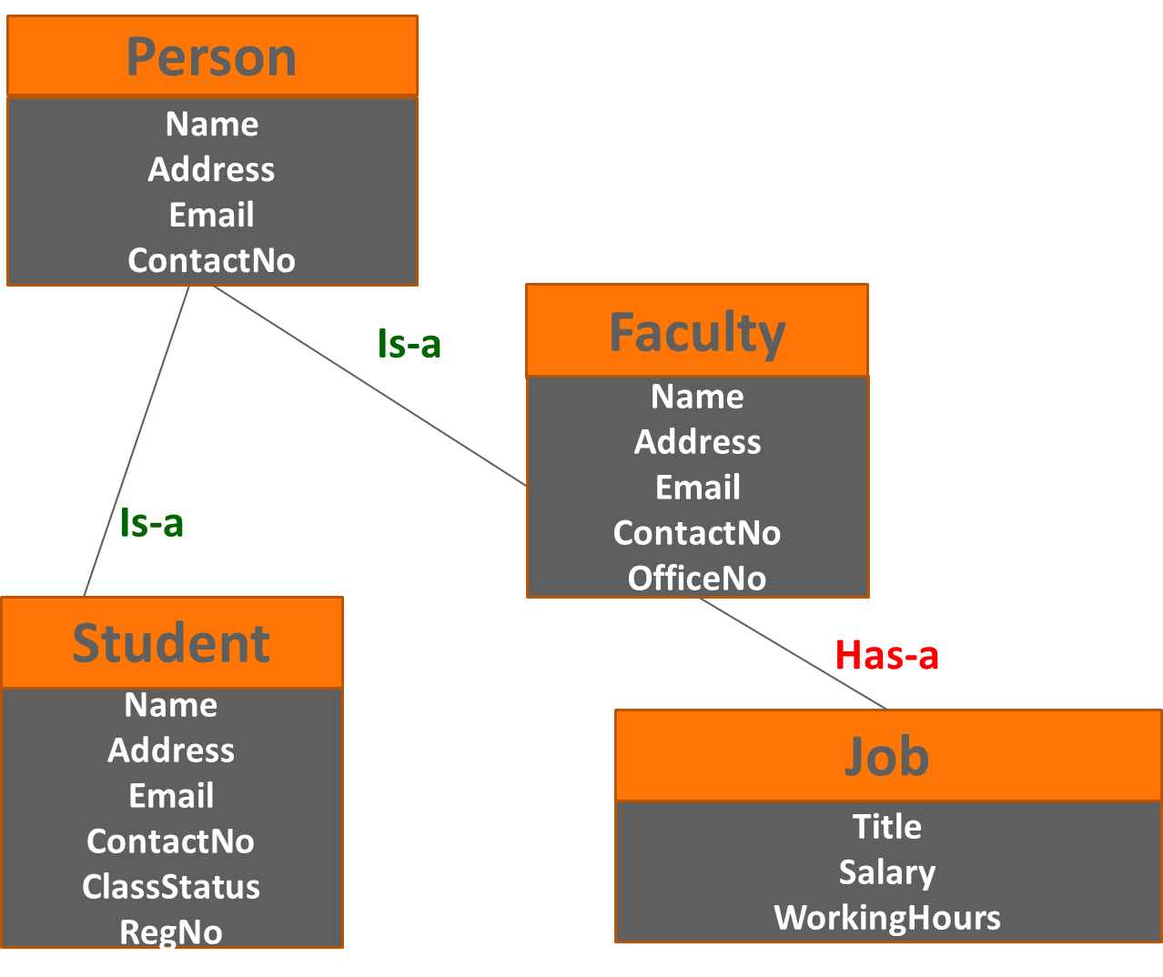

**Task #2:**

This task is the continuation of task 1. You need to slightly modify the hierarchy structure. Carefully observe the following diagram and implement it. Note: you can re-use code from task 1 where ever required.

Implement these classes with appropriate instance methods, getter setters and constructors. A test class is also required.

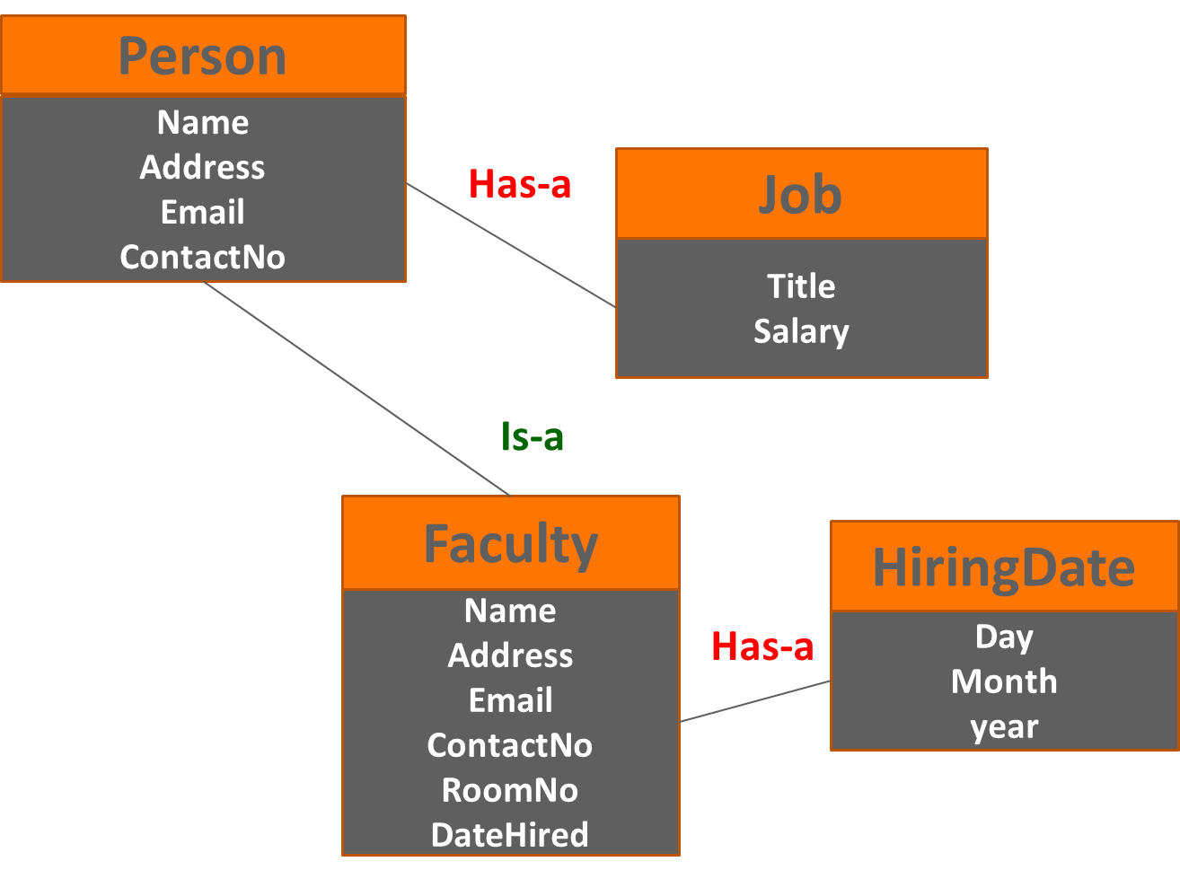

**Task #3:**

This task involves implementing the following structure. Implement using the most appropriate concepts of OOP. Also create a test class to create multiple books objects and display them.

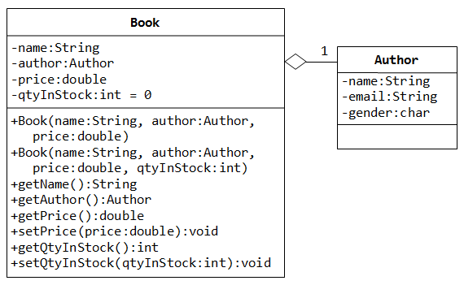

**Deliverable**

Compile a single word file and upload on LMS.